Name __________________________________

Ocean Reef Senior High School

Year 11 ATAR Psychology

Assessment Task 5 – In-class Test 2

55 marks (5% Response)

**OUTCOMES:**

|  |  |
| --- | --- |
| *Outcome 1:* | *Psychological understandings* |
| *Outcome 3:* | *Applying and relating psychological understandings* |
| *Outcome 4:* | *Communication in psychology* |

**ALLOCATED TIME FOR THE TASK:**

* *You will have one period to complete the test in class*.

**INSTRUCTIONS:**

* *Attempt all questions*
* *Complete under test conditions (no notes, files etc. to be accessed)*
* *Ensure mobiles phones are switched off and are not on your person*

|  |  |
| --- | --- |
| **Section One – Multiple Choice** | |
| **Total** | **/ 24** |

|  |  |
| --- | --- |
| **Section Two – Short Answer** | |
| Question 1 – Biological Influences | / 6 |
| Question 2 – Cognition | / 25 |
| **Total** | **/ 31** |

|  |  |
| --- | --- |
| **Total Marks** | |
| Section 1 | / 24 |
| Section 2 | / 31 |
| **Assessment Task 4 – Total Marks** | **/ 55 ( %)** |

Teacher comment: _______________________________________________________________________

______________________________________________________________________________________

______________________________________________________________________________________

______________________________________________________________________________________

______________________________________________________________________________________

**Section One- Multiple Choice Questions**

**24 Questions – 24 marks**

1. **Prolonged use of ecstasy leads to:**
2. reduced production of dopamine
3. reduced production of serotonin
4. reduced production of endorphins
5. all of the above
6. **Which of the following was NOT a finding of Field and her colleagues (2001) study into the positive effects of high levels of exercise on American high school students:**
7. students were less depressed than their peers
8. students achieved better academic grades
9. students reported better relationships with their peers
10. students engaged in less drug use
11. **The finding that aerobic exercise is an effective treatment for mildly depressed female college students was found by:**
12. Myers (2004)
13. Statistics Canada (1999)
14. McCann & Holmes (1984)
15. Field and colleagues (2001)
16. **The state of consciousness is:**
17. An awareness of the existence of ourselves and of objects and events in the external world
18. A state of mind where you only daydream and meditate
19. Not continuous, selective or changing
20. A state of mind where you focus on what you have selected to, virtually oblivious to other things going on around you.
21. **Using an electroencephalogram (EEG) to gauge a person’s level of consciousness is an example of a:**
22. subjective quantitative measure
23. subjective qualitative measure
24. objective quantitative measure
25. objective qualitative measure
26. **Which of the following is NOT usually associated with an altered state of consciousness (ASC)?**
27. inaccurate recollection of memories
28. reduced levels of suggestibility
29. distorted sense of time
30. out of body experiences
31. **States of consciousness are measured through physiological responses. Which of the following is NOT a physiological measurement of a person’s state of consciousness:**
32. brain waves
33. body temperature
34. reported level of awareness
35. heart rate
36. **Habituation occurs when:**
37. a change in the stimulation is so intense it causes us to pay attention
38. predictable and unchanging stimuli fail to command attention
39. mental effort must be divided between tasks or stimuli
40. we consciously give priority to some stimuli over others
41. **_________________ involves our sense organs receiving physical stimuli such as sound waves and light.**
42. reception
43. recognition
44. sensation
45. perception
46. **Visual illusions such as the Poggendorff illusion are useful to psychologists because they:**
47. can be used to inform a person’s level of awareness
48. outline how humans make sense of their sensory environment
49. are used in hypnosis and other states of consciousness
50. teach us from experience not to trust our senses
51. **The first person to talk about the notion of general intelligence was:**
52. Binet
53. Wechsler
54. Galton
55. Goleman
56. **Charles Spearman proposed a _______ factor theory of intelligence**
57. one
58. two
59. three
60. four
61. **Who developed the concept of mental age?**
62. Francis Galton
63. Alfred Binet
64. David Wechsler
65. Lewis Terman
66. **If Jane's intelligence quotient is 100, we know that she has a:**
67. perfect score on a set of age-related tests
68. test performance superior to 90% of other children the same age who took the test
69. mental age typical of children who have the same chronological age
70. mental age below those of children with the same chronological age
71. **Billy has a mental age of 8 and a chronological age of 10. Billy's IQ is:**
72. 108
73. 125
74. 80
75. 92
76. **Which of the following is part of Wechsler's definition of intelligence?**
77. naturalistic intelligence
78. iconic memory and eidetic imagery
79. ability to deal effectively with the environment
80. spatial and kinaesthetic abilities
81. **Emotional intelligence involves having**
82. self-control
83. self-awareness
84. self-management
85. all of the above
86. **A school curriculum built on Howard Gardner's theory of intelligence would provide:**
87. neuromuscular training because such skills underlie general intelligence
88. training in logic, rhetoric, philosophy and math to strengthen the general factor in intelligence
89. emphasis on creative, artistic abilities rather than the traditional emphasis on cognitive abilities
90. a diverse curriculum with education in skills not traditionally associated with IQ
91. **Kinaesthetic learners learn best**
92. by doing
93. by hearing
94. by using texts and watching videos
95. in calm quiet surroundings
96. **A small social group that shares activities, behaviours, values, and appearance is considered a:**
97. family
98. clique
99. subculture
100. crowd
101. **Prosocial behaviours include:**
102. helping others
103. sharing with others
104. making sacrifices
105. all of the above
106. **Bullying in schools is seen when:**
107. all the students are boys
108. all the students are girls
109. there is aggressive behaviour designed to harm others
110. teachers are unhappy
111. **The social and cultural differences between young people and older adults is**

**sometimes referred to as the _________________________________.**

1. generation gap
2. generation stage
3. generational divide
4. generational difference
5. **This diagram shows the changing structure of adolescent groups (Dunphy, 1963). Looking at the diagram, which stage reflects the start of dating?**
6. 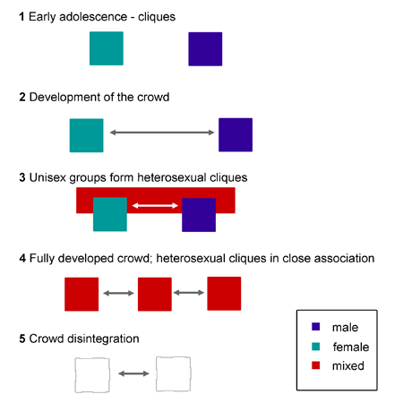stage 1
7. stage 2
8. stage 3
9. stage 4

**Section Two- Short Answer Questions**

**Two Questions – 31 Marks**

**Question One –**

**Intelligence Questions**

**Mix and match and name of theorist –**

**(3marks)**

Sensation and perception difference between – (2 marks)

Compare the processed of

Questions Two -

STATE THETY ARE FRIENDS Abdul and Anouk are first years at the University of New South Wales, Abdul came from Melbourne while Anouk grew up in Sydney. Abdul is studying Biomedicine whereas Anouk is studying Pharmacology, they have 4 yearlong modules together and attend the same lectures. Abdul and Anouk often study together, sharing notes and quizzing each other on the content.

**Are Anouk and Abdul friends, using terminology related to the Determinants of liking to explain your answer.**

Proximity, Similarity and Reciprocity

Question on Communication Q

**Question Three – Cognition *(25 marks*)**

1. With reference to the brain wave diagram complete the table below. (*8 marks*)

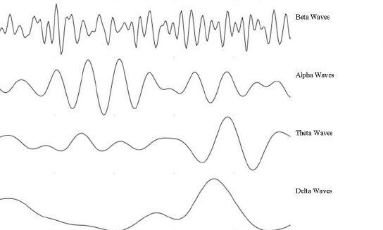

|  |  |  |  |
| --- | --- | --- | --- |
| Brain Wave | Name | Frequency (per second) and amplitude of waves | State of consciousness of the person |
| 1 | Beta |  |  |
| 2 | Alpha |  |  |
| 3 | Theta |  |  |
| 4 | Delta |  |  |

1. What is a limitation of using *observation* to measure a person’s state of consciousness? (*2 marks*)

______________________________________________________________________________

______________________________________________________________________________

______________________________________________________________________________

______________________________________________________________________________

______________________________________________________________________________

______________________________________________________________________________

1. Steven is preparing to complete a timed IQ test. He is feeling alert and slightly anxious before the start of the test, however as soon as the test starts he feels calm and confident. Steven concentrates solidly and without a break for the entire hour-duration of the test. Immediately after completing the IQ test Steven, feeling slightly tired and fatigued at his efforts, sits and daydreams for a short period.

Explain the changes in each of the measures of states of consciousness below that Steven would have experienced from before the IQ test began, through to his daydreaming at the end.

(*8 marks*)

1. *Body temperature*: __________________________________________________________

____________________________________________________________________________________________________________________________________________________________________________________________________________________________________________________________________________________________________

1. *Brain waves*: ______________________________________________________________

____________________________________________________________________________________________________________________________________________________________________________________________________________________________________________________________________________________________________

1. *Galvanic skin response*: _____________________________________________________

____________________________________________________________________________________________________________________________________________________________________________________________________________________________________________________________________________________________________

1. *Heart rate*: ________________________________________________________________

____________________________________________________________________________________________________________________________________________________________________________________________________________________________________________________________________________________________________

Psychology Multiple Choice Answer Sheet

Name: ___________________________

Please use CAPITAL LETTERS for your answers

|  |  |
| --- | --- |
| Question | Answer |
| 1 |  |
| 2 |  |
| 3 |  |
| 4 |  |
| 5 |  |
| 6 |  |
| 7 |  |
| 8 |  |
| 9 |  |
| 10 |  |
| 11 |  |
| 12 |  |
| 13 |  |
| 14 |  |
| 15 |  |
| 16 |  |
| 17 |  |
| 18 |  |
| 19 |  |
| 20 |  |
| 21 |  |
| 22 |  |
| 23 |  |
| 24 |  |

Total / 24: ____________